Week 8 - Pattern Recognition Report

Name: Swayam Rudrawar

Objective:
The objective of Week 8 was to identify hidden patterns in the collected light intensity data using unsupervised machine learning techniques. Feature engineering was performed on the combined dataset, followed by clustering using K-Means and Agglomerative Clustering. The generated clusters were analyzed to understand repetitive sensor behavior and trends.

Software and Libraries Used:
- Python
- Google Colab
- Pandas
- NumPy
- Scikit-learn
- Matplotlib
- Seaborn

Topics Covered:
- Clustering using K-Means
- Agglomerative Clustering
- Time-Series Pattern Analysis
- Feature Engineering
- Feature Scaling
- Pattern Visualization using PCA
- Correlation Analysis

Workflow:
Combined Dataset → Feature Engineering → Standardization → Elbow Method → K-Means Clustering → Pattern Analysis → Model Saving

Tasks Performed:
- Combined the cleaned Bright, Dim and Dark datasets.
- Prepared the dataset for unsupervised learning by removing class labels.
- Created additional features such as Rolling Mean, Rolling Standard Deviation and Difference.
- Standardized the dataset using StandardScaler.
- Applied the Elbow Method to estimate the optimum number of clusters.
- Implemented K-Means and Agglomerative Clustering.
- Visualized clusters using PCA.
- Performed time-series and feature correlation analysis.
- Saved the trained K-Means model and generated the clustered dataset.

Feature Engineering:
Feature | Purpose
Lux | Original light intensity
Smoothed Lux | Reduced sensor noise
Rolling Mean | Capture local trend
Rolling Std | Measure local variation
Difference | Detect sudden changes
Anomaly | Highlight abnormal readings

Pattern Recognition Results:
K-Means successfully grouped the sensor readings into three major clusters representing distinct patterns in the light intensity data. PCA visualization shows clear separation between the discovered clusters, indicating that the engineered features effectively capture the characteristics of the sensor readings.

K-Means Cluster Visualization:
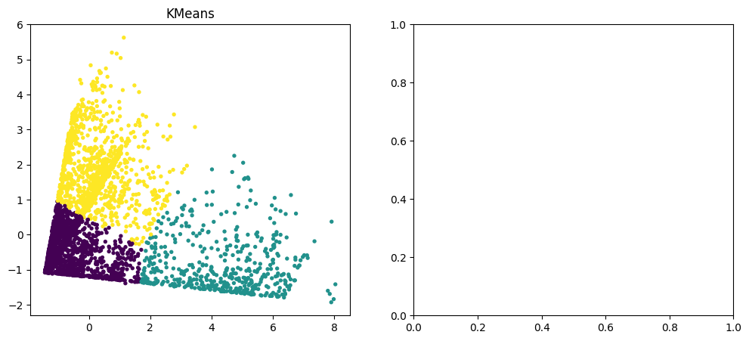

Time-Series Pattern:
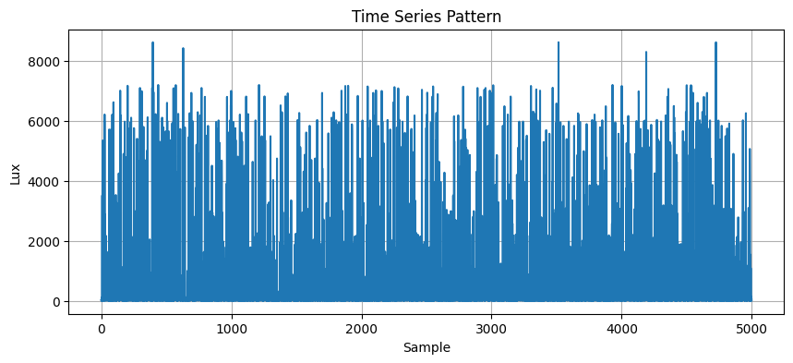

Feature Correlation Heatmap:
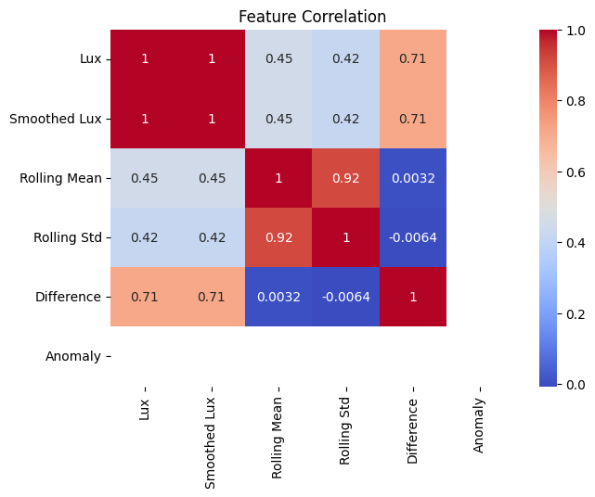

Observations:
- The combined dataset was successfully prepared for unsupervised learning.
- K-Means separated the data into three meaningful clusters.
- Time-series visualization revealed repeated changes in light intensity over time.
- The heatmap showed a very strong positive correlation between Lux and Smoothed Lux.
- Rolling Mean and Rolling Standard Deviation captured local trends and fluctuations effectively.
- The generated K-Means model can be reused for future pattern recognition tasks.

Conclusion:
The objectives of Week 8 were successfully achieved. Unsupervised learning techniques were applied to identify hidden patterns in the collected light intensity dataset. Feature engineering improved the quality of the clustering process, while PCA and time-series analysis provided meaningful visualization of the discovered patterns. The resulting clustering model can serve as the foundation for advanced predictive analytics and intelligent monitoring in future stages of the project.

